CS 340 README
About the Project / Project Title
Title: Grazioso Salvare Dashboard
This project created an interactive dashboard for Grazioso Salvare using Python and Dash that connects to the MongoDB database via the Project One CRUD module. The dashboard provides filtering by rescue type and displays results in a dynamic data table, pie chart, and geolocation map.
Motivation
Grazioso Salvare needed a user-friendly interface to identify dogs suitable for different types of search-and-rescue training. This dashboard was built to allow easy filtering of the Austin Animal Center data and visualization of suitable candidates.
Getting Started
To get a local copy up and running, follow these simple steps:
- Download the ProjectTwoDashboard.ipynb file and CRUD_Python_Module.py file.
- Place the two files in your working directory.
- Ensure MongoDB is running in Codio and the aacuser account has been created.
- Open the notebook in JupyterLab and run the main cell.
Installation
This project was developed entirely within the Codio cloud development environment. No local installation was required. Tools and libraries used:
- Python 3 -- Pre-installed in Codio. Chosen for its readability and widespread use in data-driven applications.
- Jupyter Notebook / JupyterDash -- Used for interactive development and running the dashboard.
- Dash (Plotly) -- Chosen for building the interactive web application with real-time callbacks.
- dash_leaflet -- For the geolocation map component.
- Plotly Express -- For the breed distribution pie chart.
- pandas -- For data manipulation.
- PyMongo -- Used via the CRUD module for database access.
- MongoDB -- NoSQL database for the animal outcomes dataset.
Usage
The dashboard allows users to select rescue type filters via radio buttons. The data table, pie chart, and map update dynamically based on the selection.
Code Example
# In ProjectTwoDashboard.ipynb
from CRUD_Python_Module import AnimalShelter
# Connect to database (handled in the notebook)
db = AnimalShelter("aacuser", "goodpassword")
# The full dashboard launches when the cell is executed
Tests
The dashboard was tested with all four required filter options to verify full functionality. A series of tests confirmed the following:
- The dashboard loads successfully with the Grazioso Salvare logo and unique identifier.
- The Reset filter displays the full unfiltered dataset with the pie chart and map functioning.
- Water Rescue, Mountain or Wilderness Rescue, and Disaster or Individual Tracking filters correctly apply the MongoDB queries (breed, sex, age) and update the data table, pie chart, and map in real time.
- Row selection in the data table updates the geolocation marker.
All filter states performed as expected, demonstrating successful integration between the CRUD module, interactive options, and dashboard widgets.
Screenshots
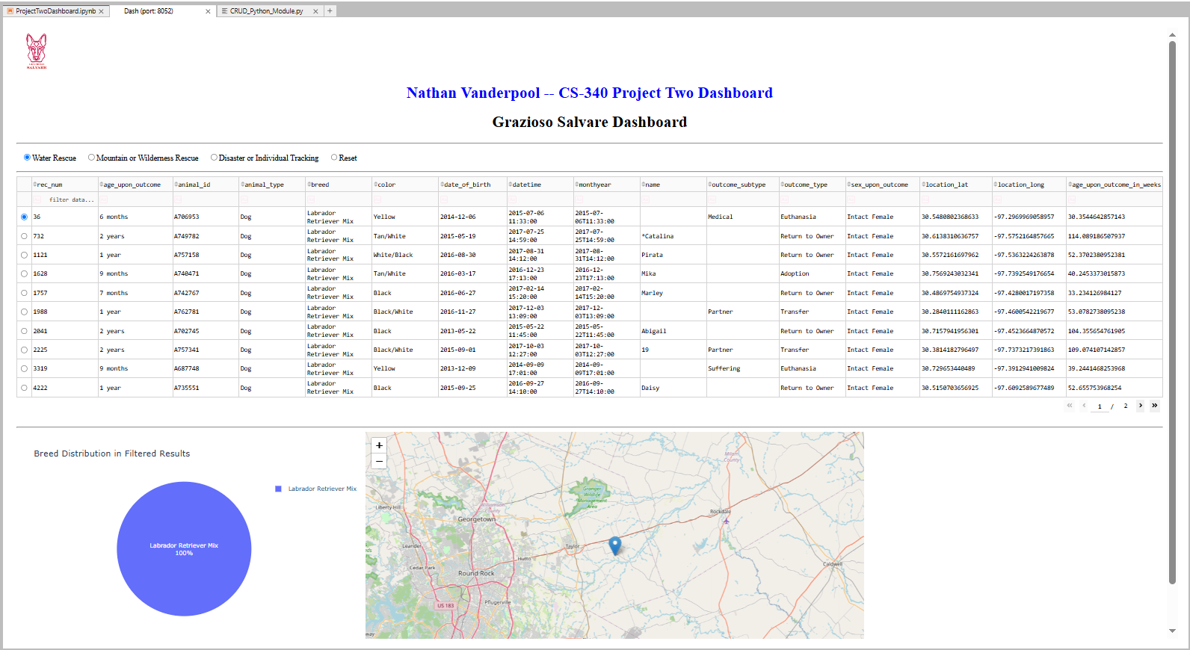
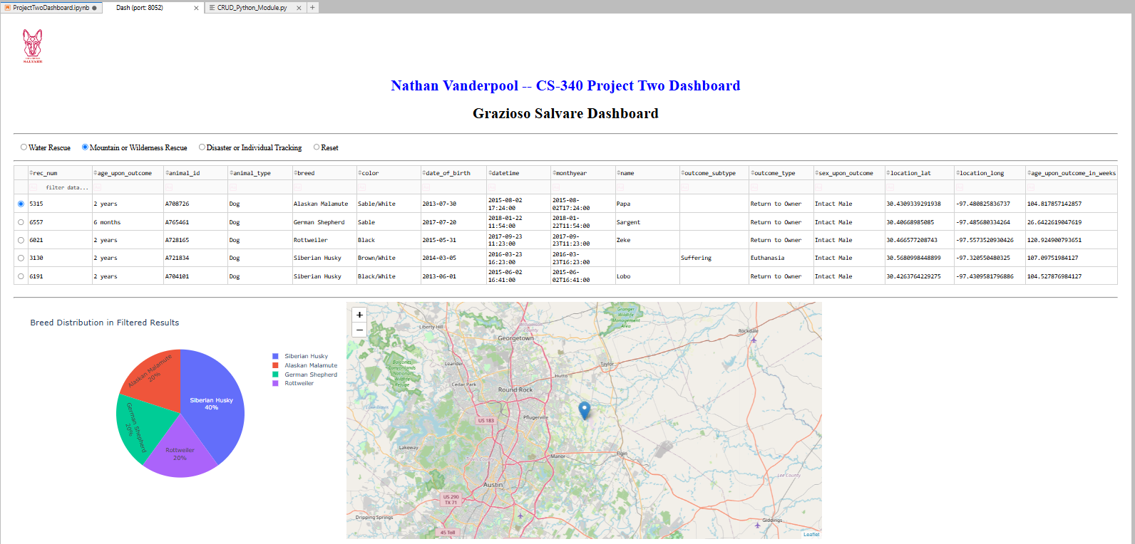
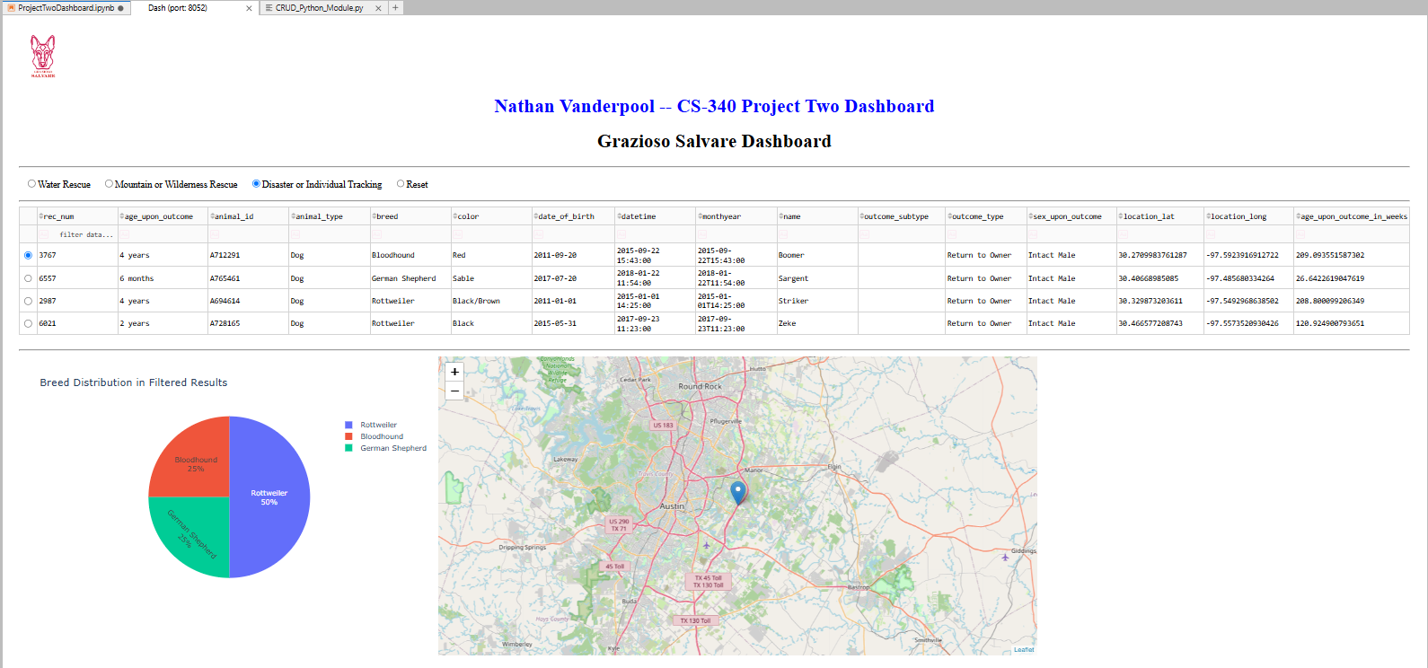
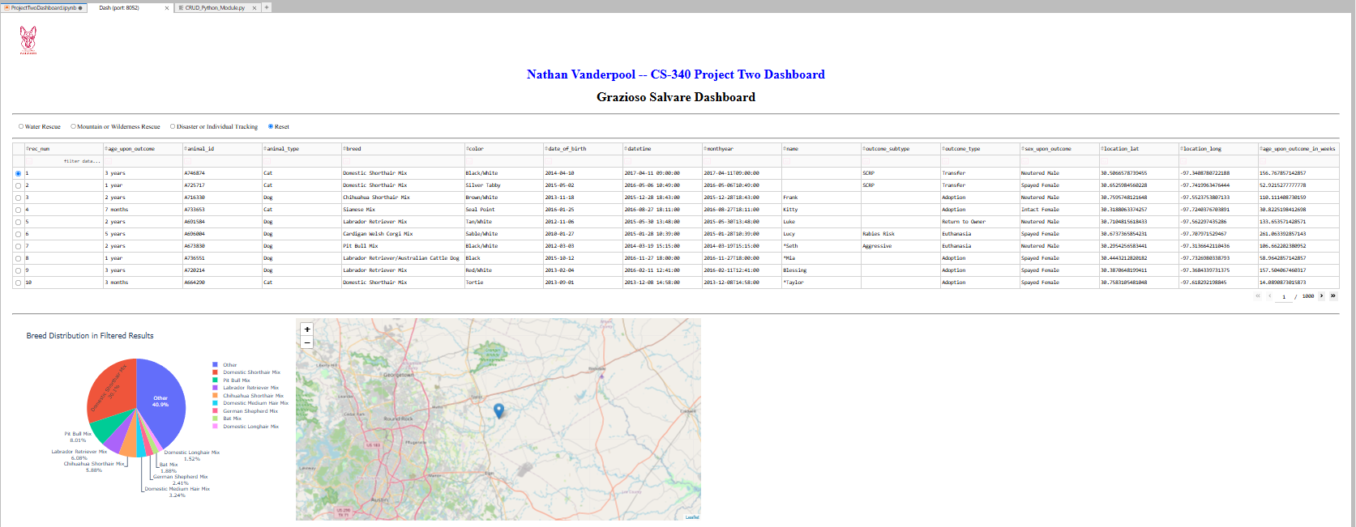
Steps Taken to Complete the Project
- Reviewed the Dashboard Specifications Document and Rescue Type table.
- Reused and integrated the Project One AnimalShelter CRUD module for all database queries.
- Built the dashboard layout with branding (logo + name), radio filters, data table, pie chart, and map.
- Implemented controller callbacks to handle filtering with precise MongoDB queries matching the preferred breeds, sex, and age ranges.
- Tested all four filter states and verified dynamic updates.
- Took required screenshots and prepared documentation.
Challenges & Resolutions
- Crowded pie chart on full dataset: Resolved by grouping rare breeds into an "Other" category for better readability.
- Column index safety in map: Added try/except blocks with defaults.
- Logo embedding: Used base64 encoding to display the image directly in the dashboard.
- Real-time updates: Leveraged Dash callbacks for seamless interaction.
Contact
Your name: Nathan Vanderpool

